

***INSTITUTE OF INFORMATION TECHNOLOGY***

***JAHANGIRNAGAR UNIVERSITY***

**Lab Exam :** 02

**Submission Date :** 24/01/2022

**Course Tittle :** Algorithm Analysis and Design Lab

**Course Code :** ICT - 2202

**Submitted To Submitted By**

Dr. M. Abu Yousuf Md. Shakil Hossain

Professor Roll – 2023

IIT – JU 2nd year 2st Semester

IIT – JU

**Answer to the problem no - 1**

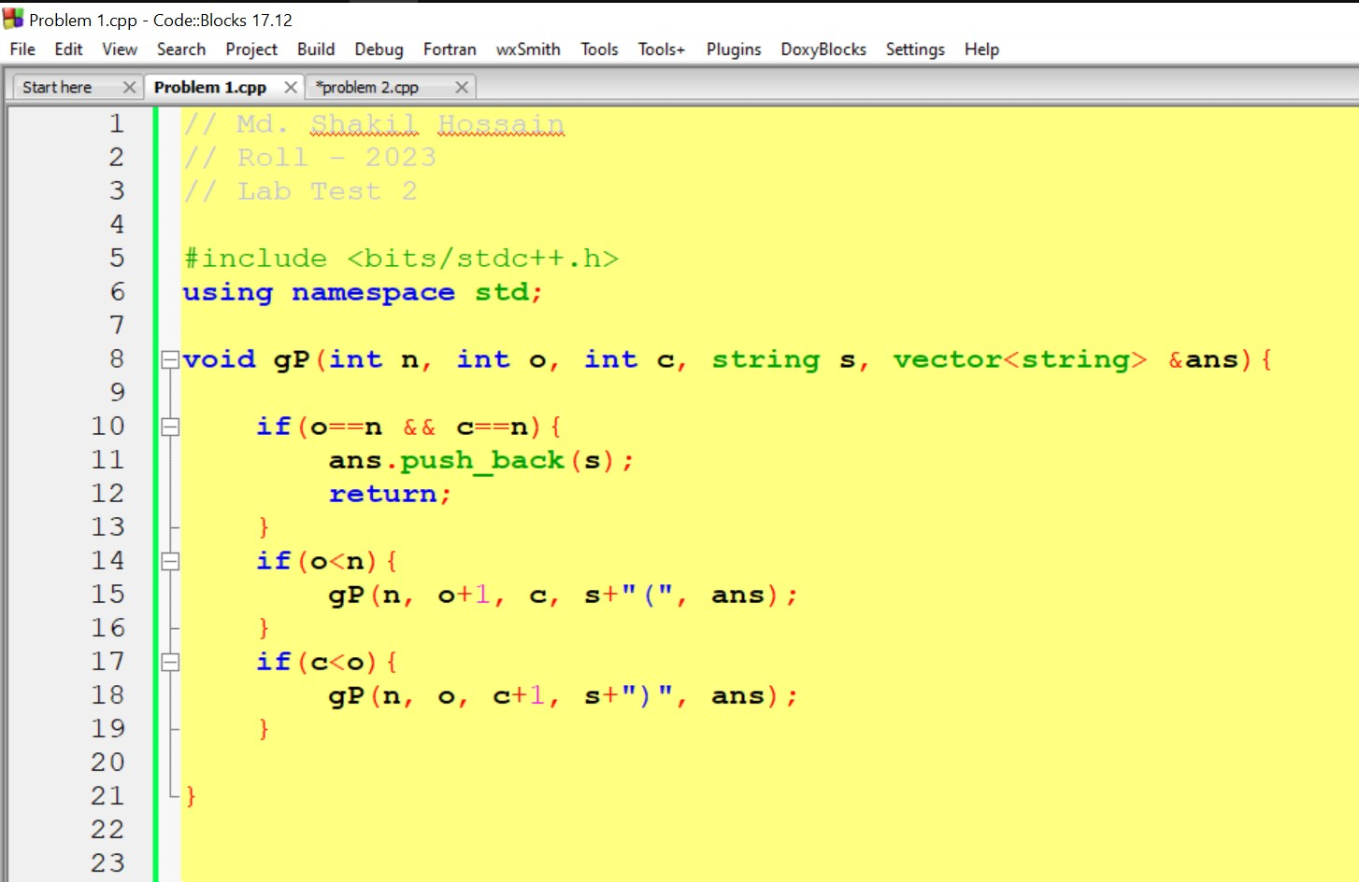

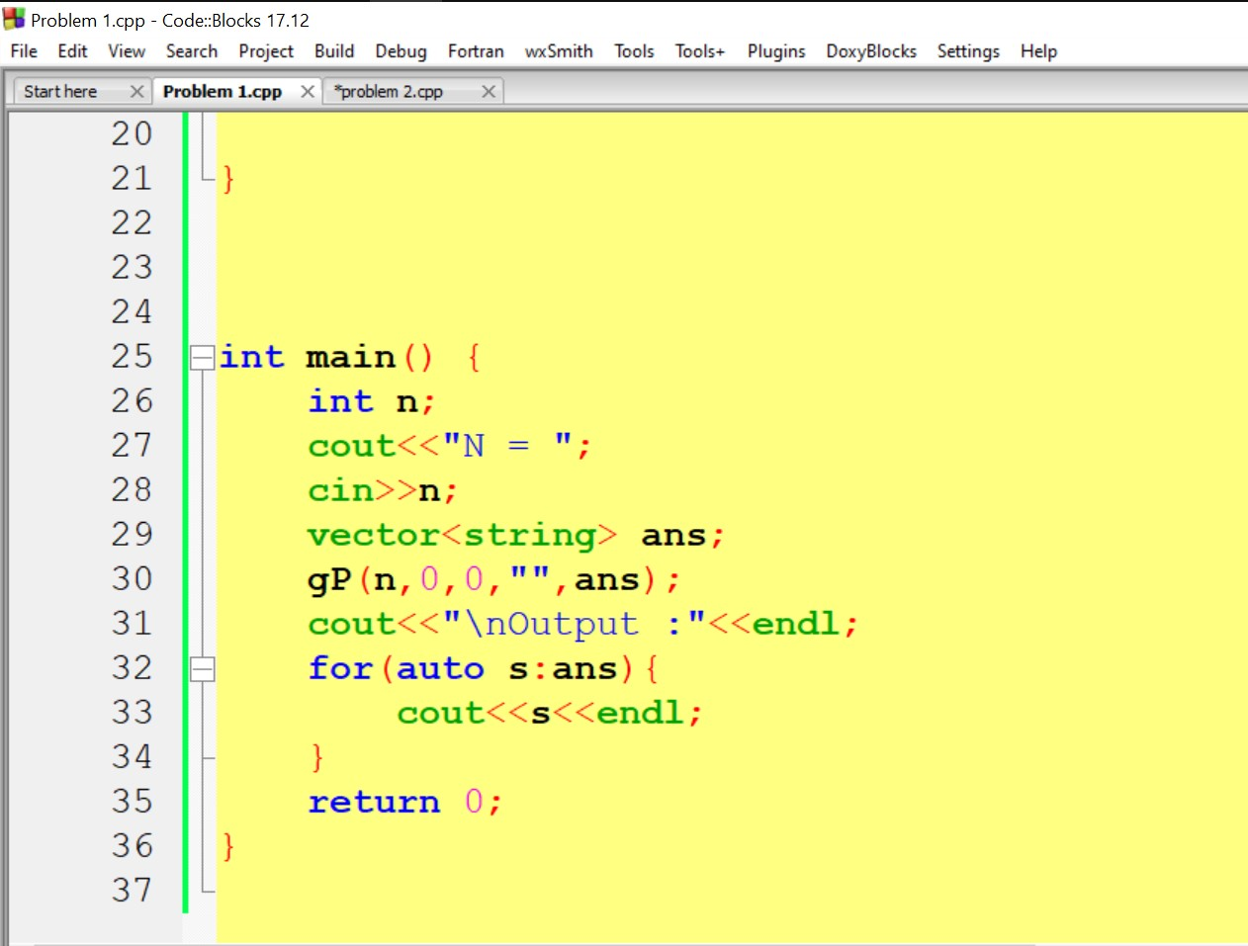

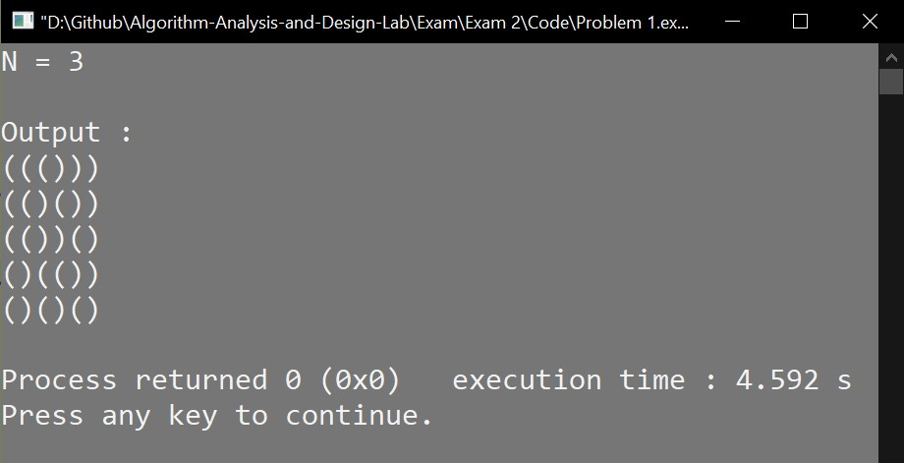

**Answer to the problem no – 2**

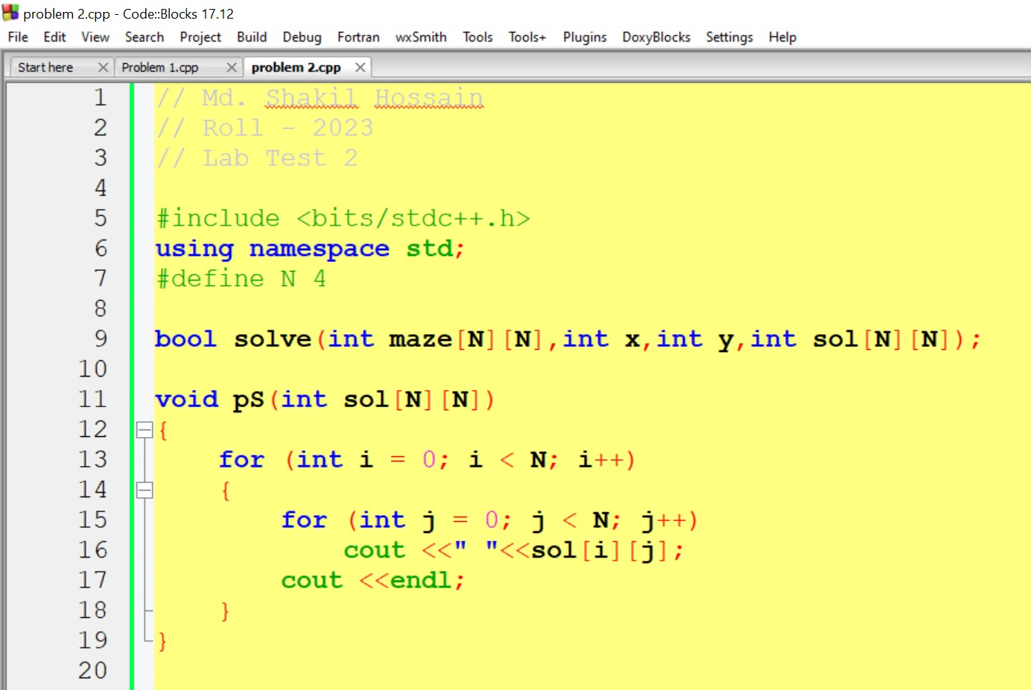

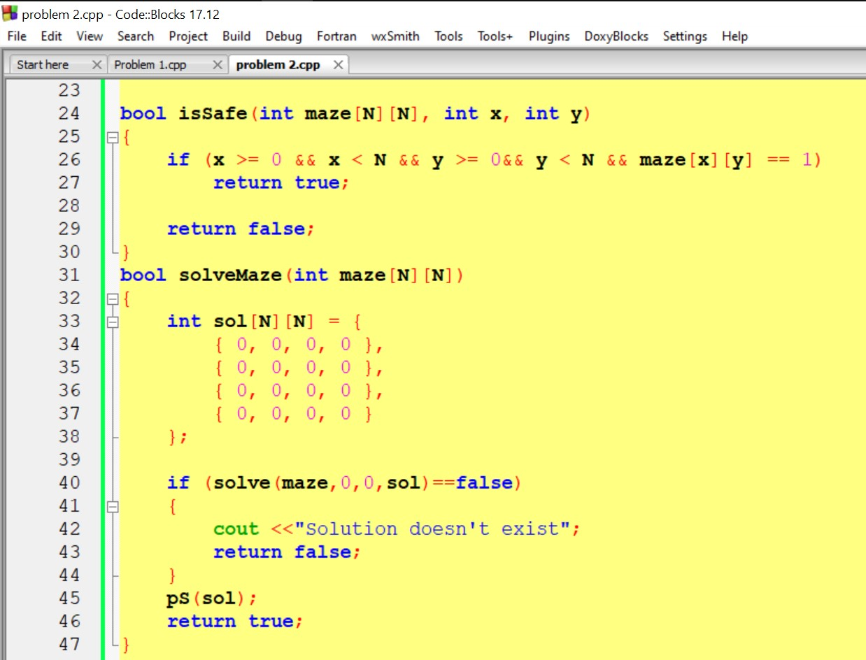

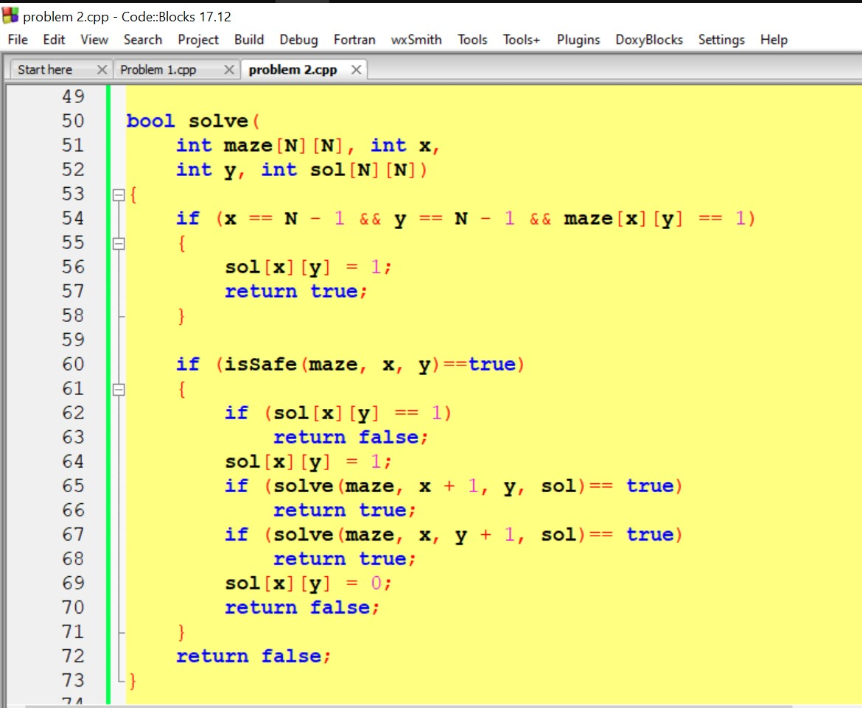

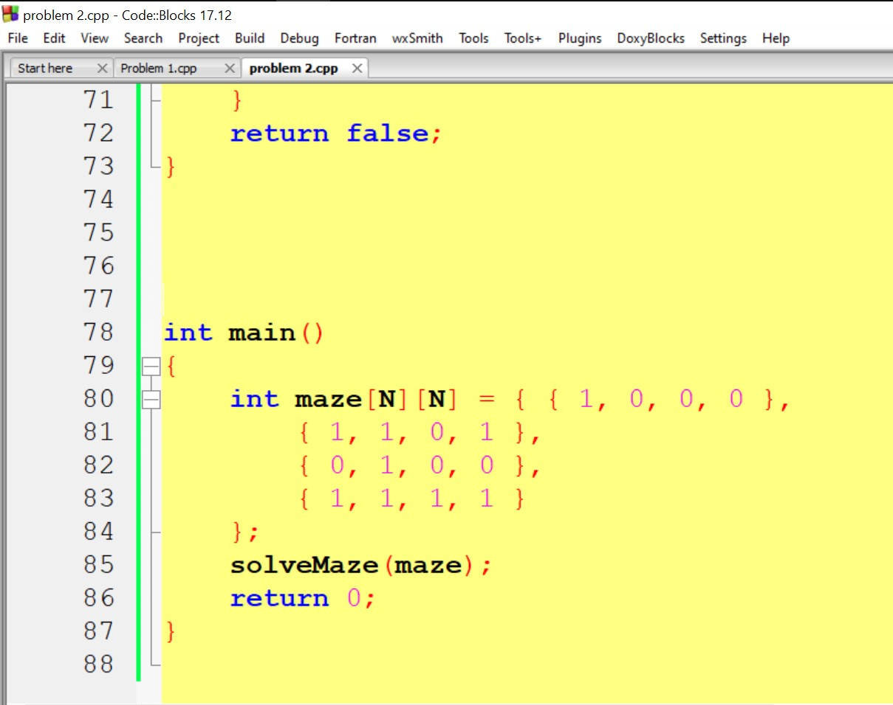

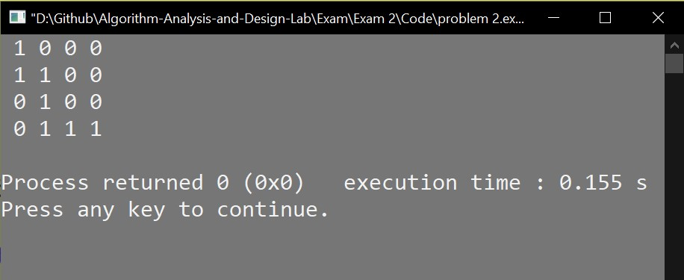

**THE END**